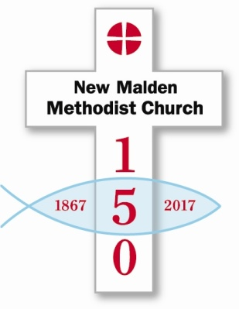
Sunday 18th June | Launch service Rev Steve Wild followed by Bring & Share Lunch  Unveiling of mosaic
Saturday 24th June | Children’s Party  Youth Event
Sunday 25th June | Church Family Picnic in Beverley Park
Saturday 1st July | Malden Fortnight Parade, Hymnathon,
Friday 7th July | Exhibition 10-2
Saturday 8th July | Exhibition 10-4  Celebratory meal with entertainer
Sunday 9th July
Tuesday 11th July | Meeting Point  Robin Gill –History of the local area with reference to NMMC 150A
Saturday 15th July | Malden Fortnight concert TBC?
Sunday 16th July | Junior Church Festival  Church Family BBQ

