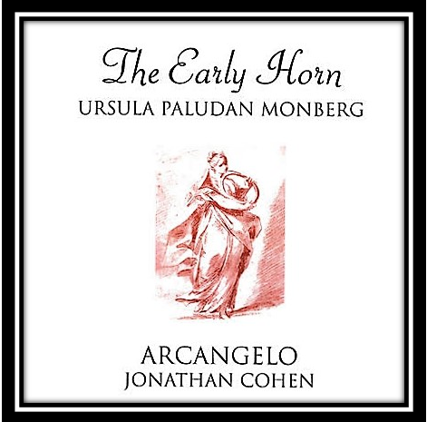
MUSIC IN NEW MALDEN – 1 September 2020
Series 13 is almost upon us!
While we can’t (yet) welcome you into our much-cherished space of New Malden Methodist Church for the kickoff, we are delighted to be able to bring you a filmed concert recorded in there at the beginning of September by Ursula Paludan Monberg and John Irving.
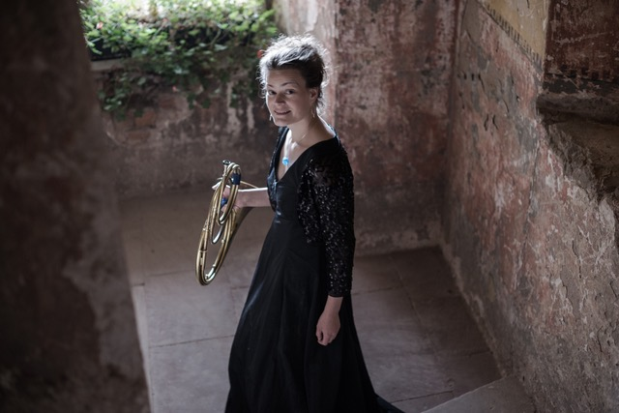
Some of you may remember their recital for us in Series 10. Their return visit features some gems of the nineteenth-century horn repertoire by Jacques-Francois Gallay - principally his Chants du Coeur: Melodies Favorites de Schubert. Ursula and John will also be playing pieces for solo horn by Gallay and for solo piano by Schubert, and their programme will end with the finale from Carl Czerny’s Brillante Fantasien - an imaginative virtuoso setting of Schubert songs.
This will be ready to view from our YouTube channel from 3.00pm on Sunday 13 September (we’ll send you a reminder with the link, along with the programme!).
You may be interested to read some comments about Ursula’s recent CD The Early Horn (available on Hyperion Records):
‘Monberg is demonstrably a master of her instrument’ Gramophone
‘...consummate playing technique’ Early Music Review
‘... thoroughly in command of her instrument’ BBC Music Magazine
Meanwhile, if you missed the July concert (also recorded), then you can still watch John Irving’s selection from Bach’s 48 Preludes & Fugues on our YouTube channel:
https://www.youtube.com/channel/UC1HVMNvDCIlXPDJn9ZcoUQw
We also wanted to advise you of a few other pieces of news. We are very much hoping that you will all continue to support Music in New Malden in the future, and you will be aware, that not having been able to put on concerts from last March onwards, the organisation is needing to think about its fundraising in order to continue to bring a music offering to New Malden. As a result, we would like to set up a membership scheme for Music in New Malden, and we would like to ask you all to become members, for an annual fee of £5. This would ensure that you received all the latest news and details of forthcoming concerts (and digital offerings) and membership would entitle members to attend a special event, which would be held annually at part of the Annual General Meeting of the group.
We very much hope that you will be happy to contribute this small amount towards the running costs of Music in New Malden. We will be able to advise you shortly of how we will be implementing the payment scheme and also follow up with details of when our AGM event will be planned.
Just also a reminder that the next concert is scheduled for
Sunday 11 October at 3pm.
We very much hope that you will enjoy the forthcoming series.

