NEXT WEEK, beginning Monday 22 December 2025
The collection for Sunday 14 December amounted to £58.21
Wednesday 5.00pm Christingle Service
8.00pm Christmas Eve Communion
Thursday 10.30am Christmas Day Service
Sunday 10.00am Tree dismantling

Prayer of the Week
God of infinite love,
as we celebrate the birth of your Son, Jesus Christ,
we pray for all those for whom Christmas is a difficult time,
especially those who are bereaved,
people who are reluctantly on their own,
those unable to be fully themselves around their family,
and all for whom the expense is just one more added pressure.
May this church be a place of light and love for all,
in the Christmas season and beyond.
Amen


This week’s flowers have been kindly donated by John Tarrant and arranged by Julia Morton.

Sign-up
Sign-up sheets are now available for the following:
- Flower Rota 2026
- Sunday Morning Worship in January
- Saturday Charity Bake Sale

Christmas Day
If you are coming to the Christmas Day Service don’t forget to bring your most interesting present.

Say goodbye to the Christmas Trees
Next Sunday – 28 December – there will be no service but plenty of fellowship as the Christmas trees are dismantled. The church will be open as usual from 10am and coffee will be served from 11am. Please come along prepared with dustpan and brush to sweep up needles as we listen and perhaps sing along to carols!

Saturday Charity Bake Sale
From the new year NMMC personnel will be running the Café on every first Saturday of the month. There is a sign-up sheet for the first six months of 2026 on the Noticeboard. If you can help on any of these Saturdays please put your name in the space provided.

Christmas wishes
John and Carol Dadds would like to wish everyone at NMMC a Blessed Christmas and a Happy and Peaceful New Year.

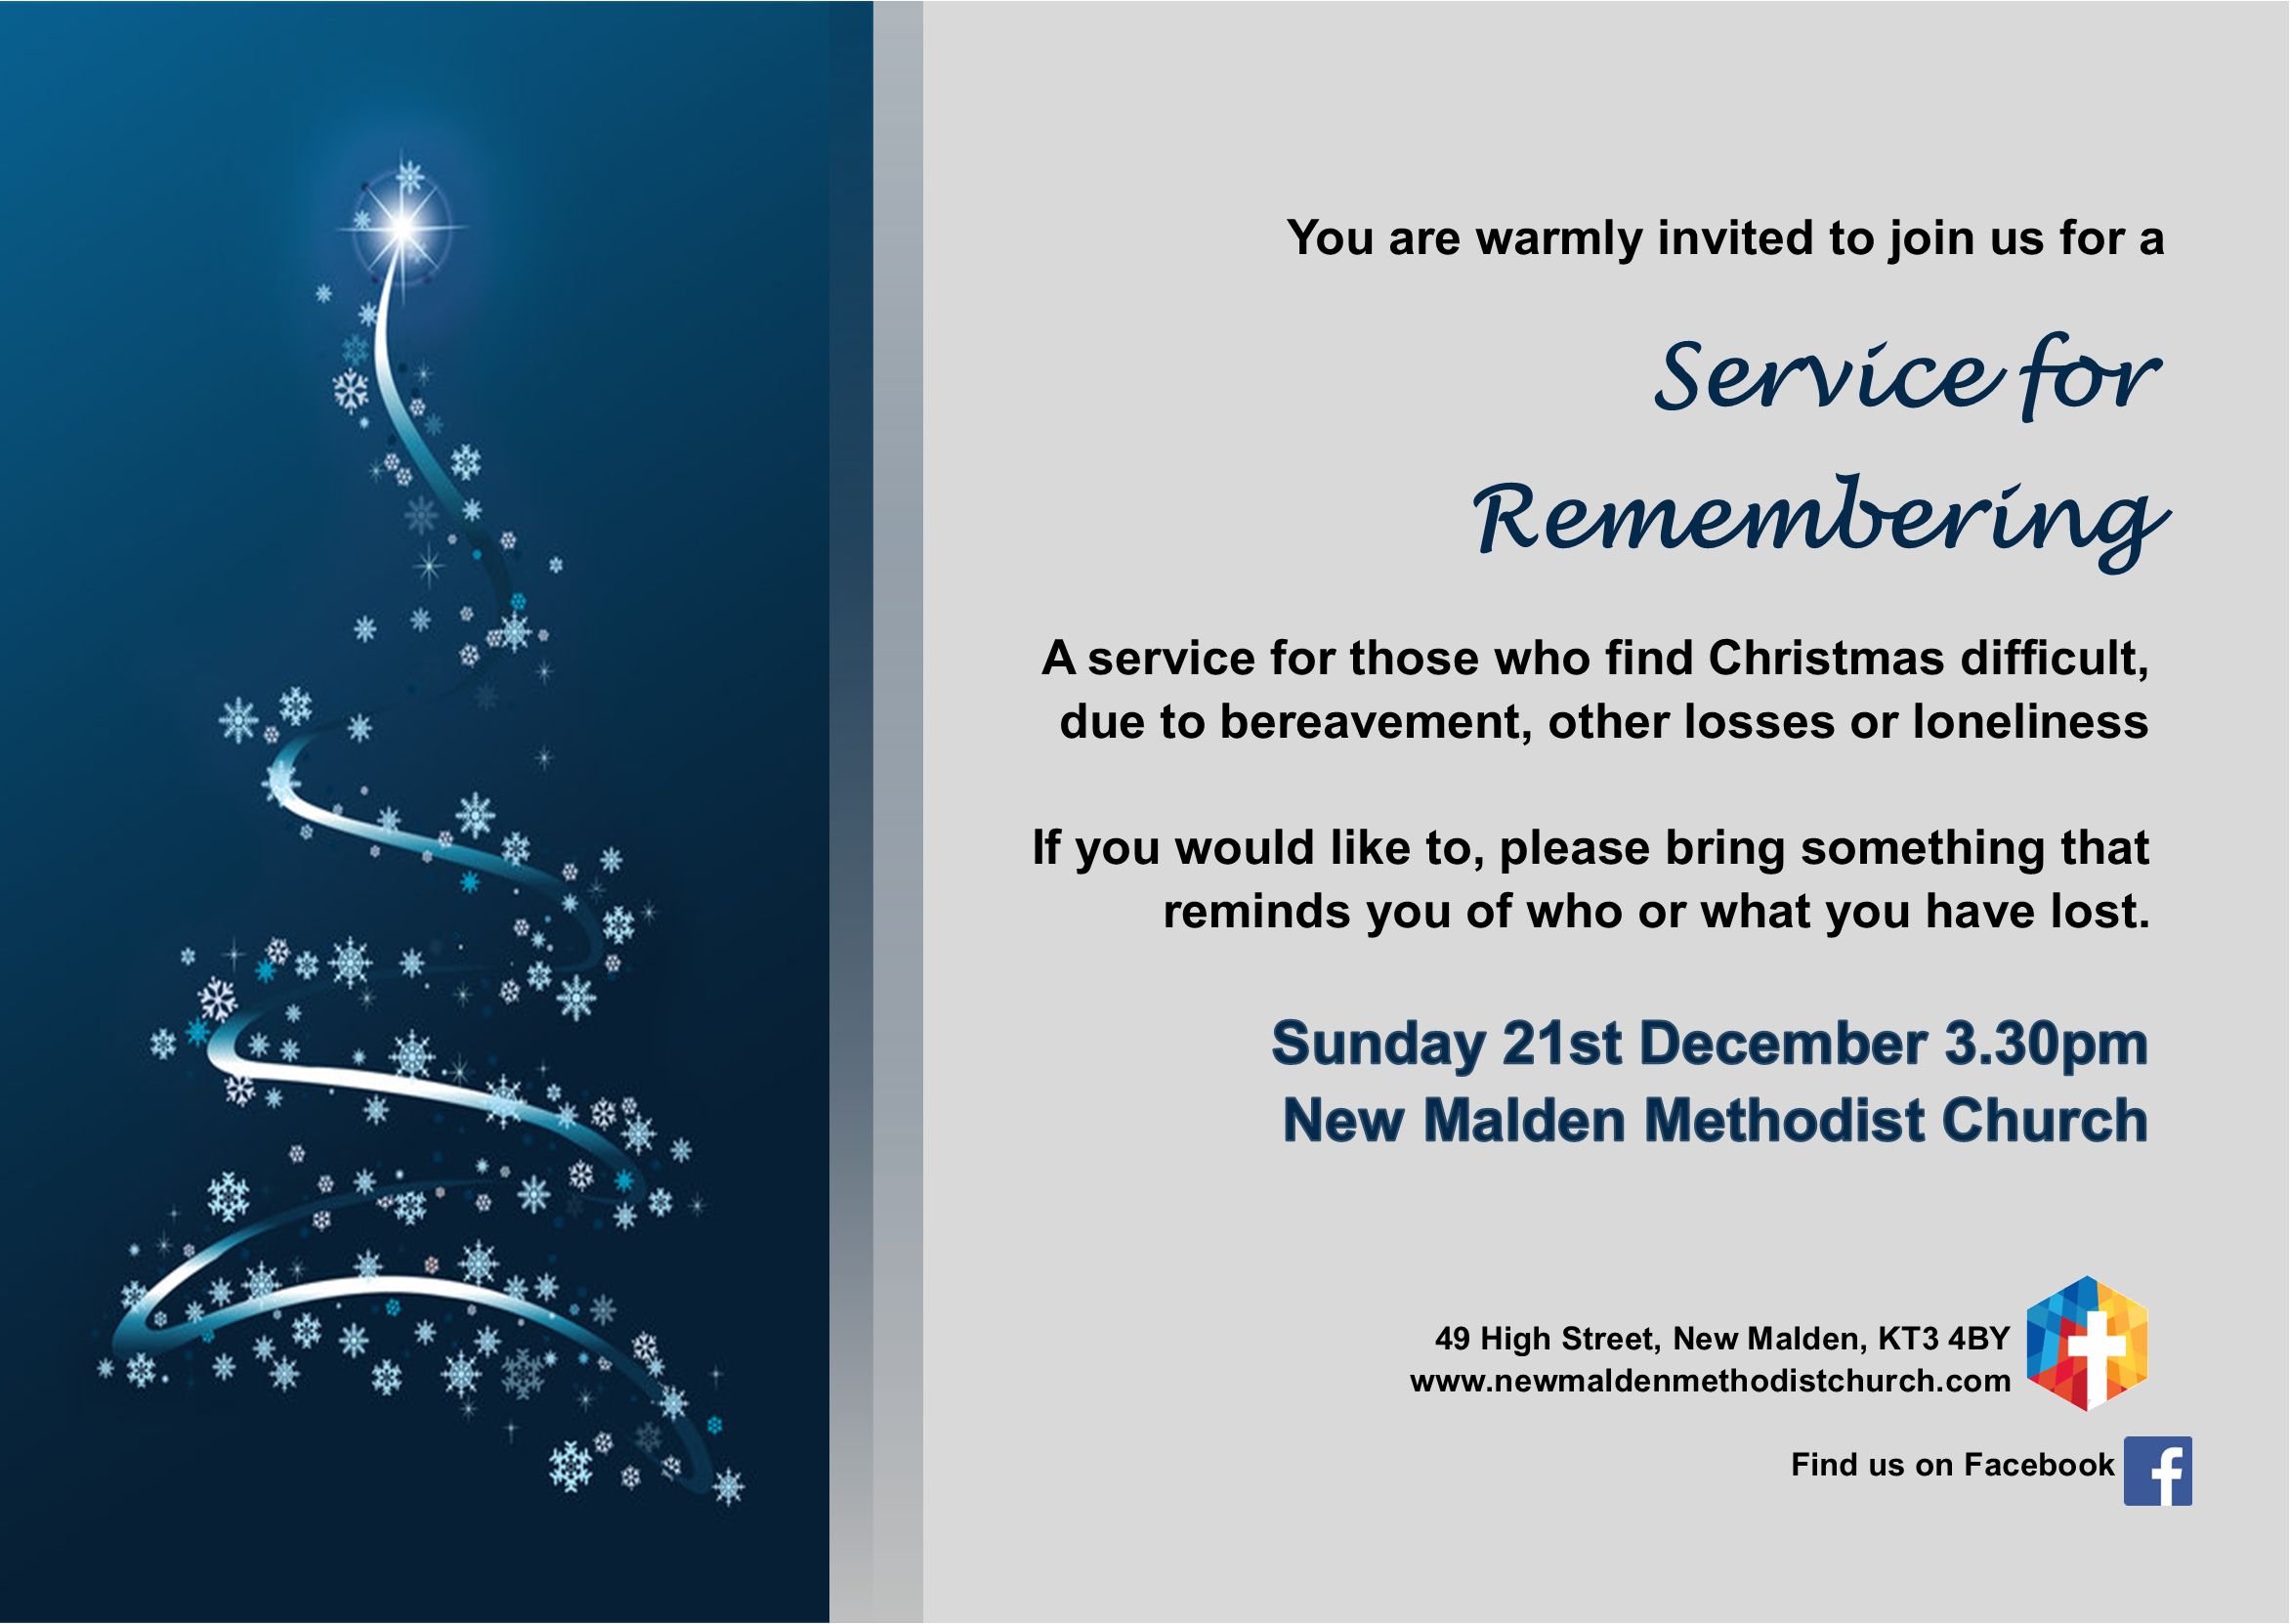

Out of Office
Barry will be away from the office this coming week and the office will be closed the following week (WB 29/12) – back to normal on Monday 5 January 2026.

Encounter 2026
Ever wondered what God is calling you to?
Would you like to have a greater impact as a Christian disciple?
Invest in your faith journey in 2026: join with others on Encounter to explore your gifts and vocation.
Find out more and book your taster session online at methodist.org.uk/encounter

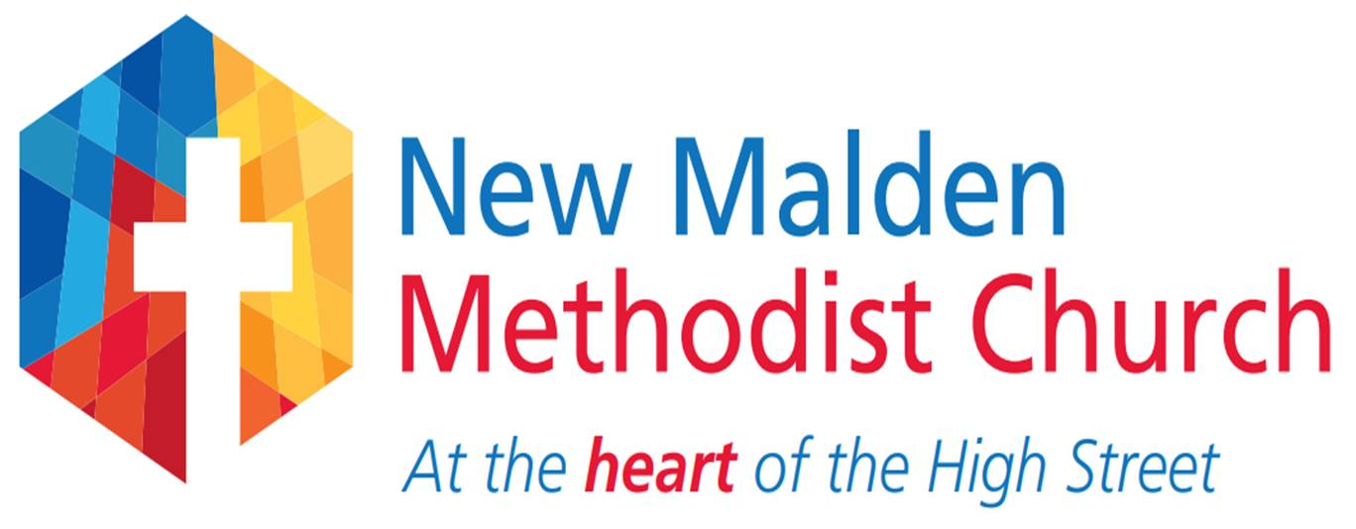
Church contact information – www.newmaldenmethodistchurch.com
 NMMethodists

Revd Dr Karl Rutlidge (Minister) 07932 242789 karl.rutlidge@methodist.org.uk
n/a Monday
Mr Barry Sawyer (Administrator) 020 8942 1288 (Church Office) nmmc@hotmail.co.uk
Mrs Lee Monczak (Development Officer) nmmc.wesleys@hotmail.com
Mrs Julia Morton (Steward) 020 8942 2657 juliamorton@virginmedia.com
Mrs Liz Edwards (Steward) 020 8949 4023 lizedwards513@gmail.com
Mrs Julie Haines (Steward) 020 8395 0202 juliehaines53@gmail.com
Charity Registration Number 1176621

Fourth Sunday in Advent

21 December 2025

10.30am Lessons and Carols
Led by Rev Dr Karl Rutlidge

WELCOME

It is good to have you with us today, sharing in our Worship. If you are a visitor, new to the area, or just beginning to attend this Church, we hope you will feel at home, and that you will come again.

Tea and coffee is served in the Welcome Area (Wesley’s) after Morning Worship. Please stay so that we can get to know one another.

So that we may keep in touch, please fill in your details on the Welcome card in the church chairs.

Large print hymn books and Korean-English Bibles are available:
한영성경을 사용하고 싶으시면 안내하시는 분에게 이야기해 주세요.


Please use this QR code if you wish to donate online to the work of NMMC.

