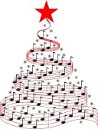**Christmas Services**

**Sunday 28th November 10.30am Festival of Lights**

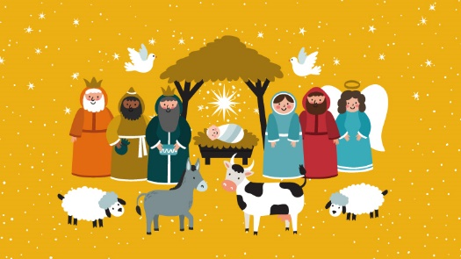**Sunday 5th December 10.30am Gift Service**Donations of luxury goods for Food Bank

**Sunday 12th December 10.30am Nativity**‘A Lad in a Manger’. A simple and straightforward radio play/panto type nativity.

**Sunday 19th December 10.30am Lessons & Carols**The traditional Nine Lessons & Carols service, but at the Sunday morning service.

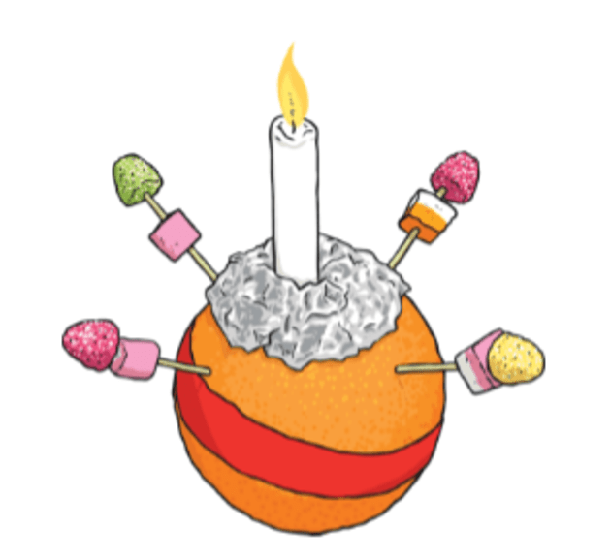  
**Tuesday 21st December 7.30pm Blue Christmas**A quiet contemplative service for people finding Christmas difficult due to disappointment and bereavement.

**Friday 24th December 5.00pm Christingle**Entrance by ticket only so that we can monitor the numbers. Apply to Church office

**Friday 24th December 8.00pm Communion Service**To replace 11.45pm service.

**Saturday 25th December 10.30am Christmas Morning Service**

**Sunday 26th December NO SERVICE**

**Sheep Trail**

We will also be organising the Sheep Trail so collect your entry form from the church (from 4th December at our Christmas Fair) and keep an eye out for the knitted sheep in shops down the High Street!

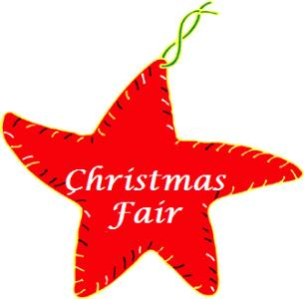**Christmas Fair ‘Lite’**

**Saturday 4th December 10am – 1pm Christmas Fair ‘Lite’**

We are not able to hold our fair in the same way as we usually do due to the continuing presence of Covid and our need to keep ourselves and our neighbours safe. For this reason, there will not be a parade in the High Street this year to switch on the Christmas lights.

However, we will be having a smaller Fair on Saturday morning, 4th December to coincide with the Farmers’ Market in the High Street.

Stalls will be quite far apart in the Sanctuary. Sanitiser will be readily available and staff and stall holders will wear visors. Customers will be asked to wear masks and a one-way system will be operated.

Stalls will be:

Cakes and other baked goods Jams/Preserves outside weather permitting   
Hot Sausage Rolls Cuddly Toy Tombola Knitwear & Crafts  
Raffle Books & Puzzles Toiletries & Jewellery   
Christmas Stall

Proceeds to charity

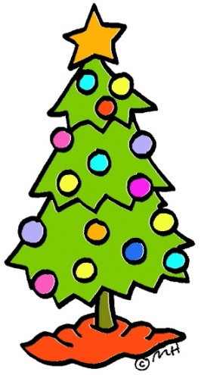

**Christmas Tree Festival**

**Saturday 11th December: 10.00am – 4.30pm  
  
Saturday 18th December: 10.00am – 2.00pm   
Weekdays: 11am – 1pm when Wesley’s is open**

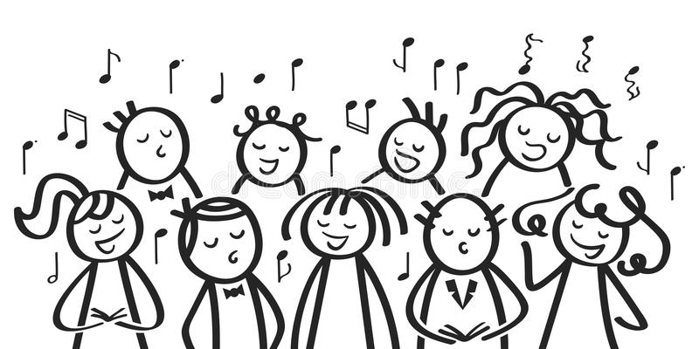**Coffee & Carols**

**Saturday 18th December 11.30 – 12.00  
Coffee & Carols**Carol singing in the High Street.